Day 1
HTML

<!DOCTYPE html>
<html>
<body>
<p>Hello World.</p>
</body>
</html>

Syntax
<p class="my-para">Hello World.</p>
- HTML uses elements to describe the structure of pages.
- Elements are made up of tags.
  - Usually two tags, an opening tag and a closing tag.
  - The closing tag has an extra forward slash in it.
- Attributes tell us more about elements.
  - They appear on the opening tag of the element.
  - Made up of two parts: a name and a value, separated by an equals sign
Date 2
<body>, <head> and <title>
<html>
<head>
<title>My page title</title>
</head>
<body>
<p>My para</p>
</body>
</html>

- Everything inside body is shown inside the main browser window.
- head contains information about the page.
- The contents of the title element are shown on the tab of the page.

Text
- Headings
- Paragraph
- Bold and italic
- Superscript and subscript
- White space
- Line breaks and horizontal rules
- Strong and emphasis
- Quotations
- Abbreviations and acronyms
- Citations and definitions
- Author details
- Changes to content

Heading

<h1> to <h6> tags are used for the heading purpose

From h1 to h6 size decreases gradually
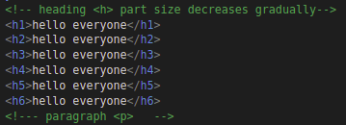
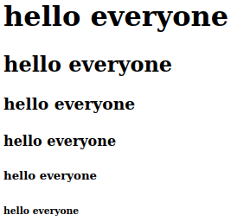

Paragraph <p>
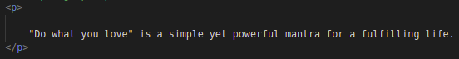

Bold and italic

Bold<b>

italic <i>
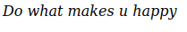

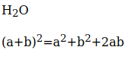
Subscripts <sub> and Superscripts <sup>
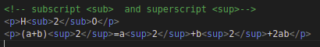

Whitespaces <pre> tag is used

For suppose we include spaces in the paragraph <p> tag then it wont be reflected back to the paragraph

To include all the spaces which we have mentioned in the code we ‘ll use <pre> tag

mention the <pre> tag in the <p>

Line Breaks <br> and Horizontal Rules<hr>

<br> and <hr> are the self closing tags ..It means that it doesn’t have the closing tags
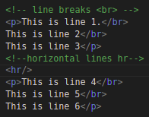
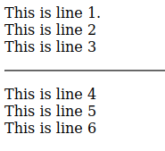

STRONG <str> & emphasis <emp>

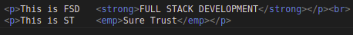

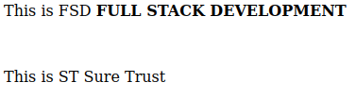

What is the difference between <strong> and <emp> tag

Semantic Meaning: <strong> is a semantic HTML tag that is used to indicate that the enclosed text is of strong importance or emphasis. It implies that the text is of greater significance within its context.

Semantic Meaning: <b> is a non-semantic HTML tag used to apply bold formatting to text without conveying any specific semantic meaning. It simply makes the enclosed text appear bold, but it does not provide any information about the significance or importance of the text.

Quotations

blackquote
Same like the paragraph and it gives some space in the starting of the every line in the paragraph

<q> tag is used to add the quotes to the text
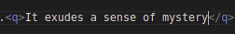

cite="lorem" is used to specify the source or citation associated with the content within the <blockquote> element.

Abbreviations and acronyms

<abbr> tag is used for abbreviations

Citations and definitions

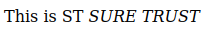
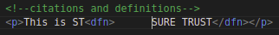

Changes to content

<str>

<del>

DAY 3

Table Creation and Adding rowspan and colspan

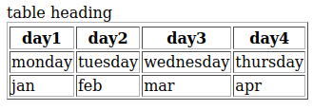
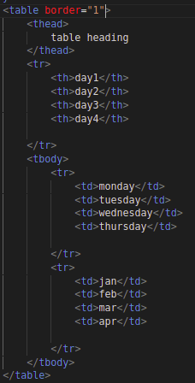

Adding the rowspan and colspan
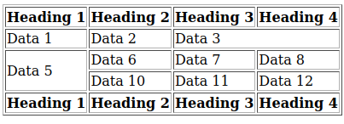
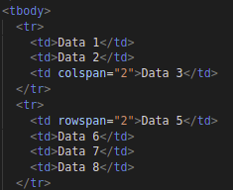

Links:

Syntax:

<a href=”https://www.google.com/”>Google</a>tag

* Links are created by using the <a> element
* Users can click on anything between the opening <a> and closing tag</a> tag.
*We specify which page we want to linkto using the href attribute
*The text between the opening tag and closing tag is known as link text
* Browsers show links in blue with an underline by default.

TYPES OF LINKS
1)Links from one website to another website
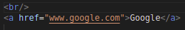
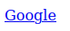

2)Link from one page to another page on the same website
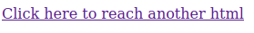
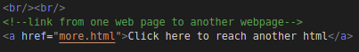
3)Link from one part of the web page to another part of the same page

we can achieve this with the help of the id
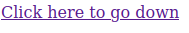
As soon as we clicks on this button then it goes down

4)Link that open in a new browser window
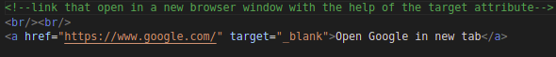
5) Link that start up a new mail program and address a new email to someone
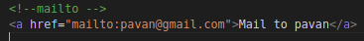
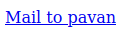

Types of lists

1)Ordered lists
2)Unordered lists
3)Definition lists

Ordered lists <ol>
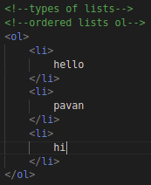
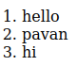

Unordered lists <ul>
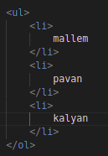
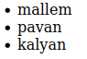

Definition lists <dl>
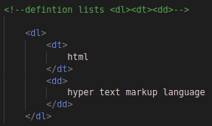
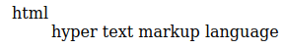

image tag
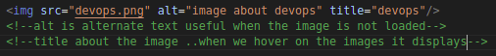

<figure> tags

figure tags are mostly used when the website contains the pseudocodes
& image followed by text etc....

<figure> element contains an image and a caption associated with it. The use of the <figure> and <figcaption> elements helps convey the relationship between the image and its description, making it easier for both humans and machines to understand the content...

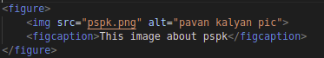

day 4

Forms

we are using the forms to store the users values..
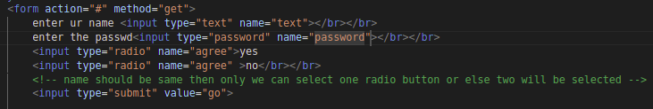
methods are of two types they are:

1)get –whatever we have submitted can be viewed in the url once we submmited the form

get method is used once the users info is not personal/sensitive
2)post
whatever we have submitted cannot be viewed in the url once we submmited the form

action =”#” we’re mentioning the path of the html i.e once we have submitted the form where we have to send those data

size and maxlength

size is used to increase the cell size
max length is used to max capacity to store the text data

once we specify the maxlength then we can’t enter the values if the max length is exceeded

Drop down

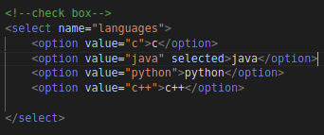
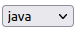

Here selected is placed to fix the value by default

Checkbox
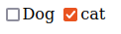
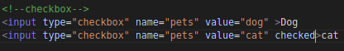

checked means autoselecting the checkbox without the permission of the user

Fieldset and legend
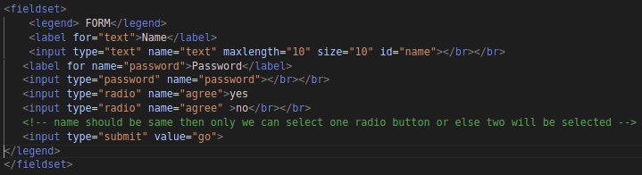

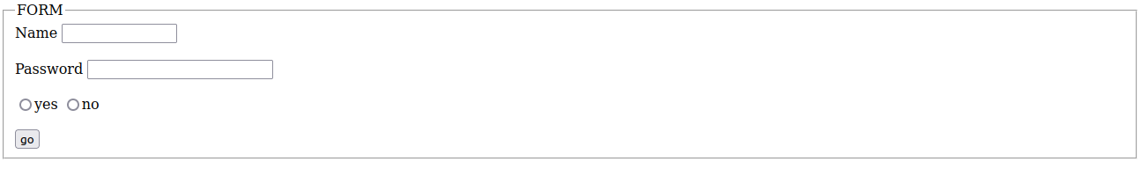
date url search email
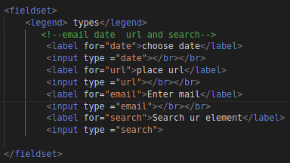

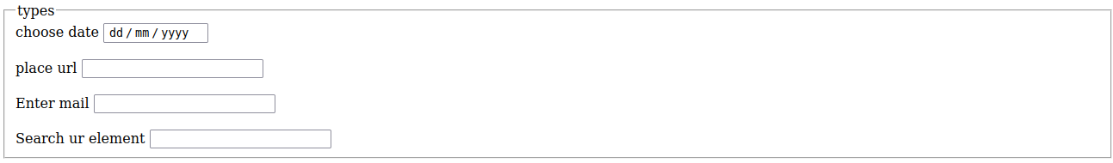
id and class attributes

id and class attributes :known as the global attributes because it can be used on any element

block elements

Block elements that are used to structure the layout of a web page by creating distinct blocks or containers.

Examples:

<h> <p> <ul> <li>

inline elements

Inline elements are elements that are used within the flow of text or other content to apply specific styling or create minor structural elements.

Examples:

<a> <b>
<emp> <img>

